### Lab-3: Implementation of Logistic Regression using Python

Date: 03-05-2024

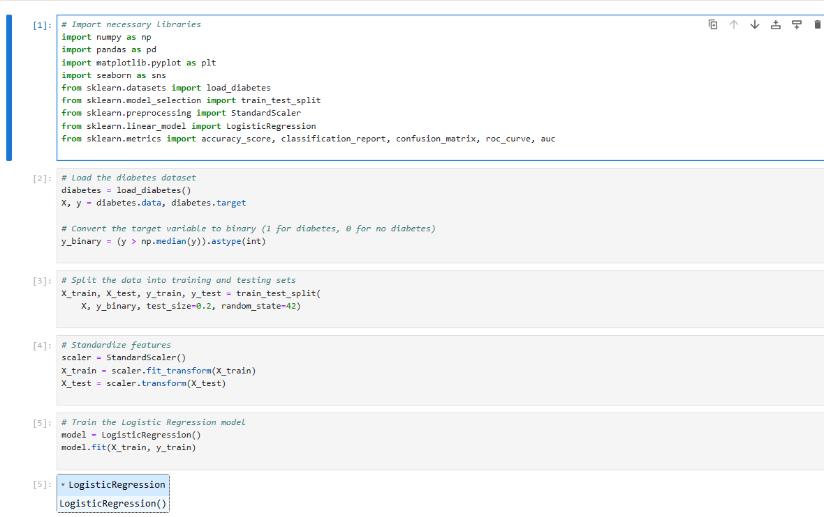

**1. Import Libraries :**

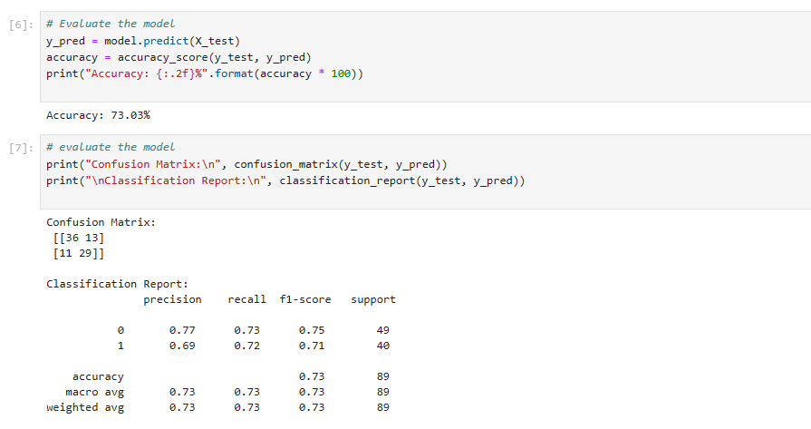

#### **2. Read and Explore the Data :** Splitting The Dataset: Train and Test dataset Feature Scaling

#### Train **Confusion Matrix and Classification Report** Metrics

#### **3. Visualizing the performance of our model.**

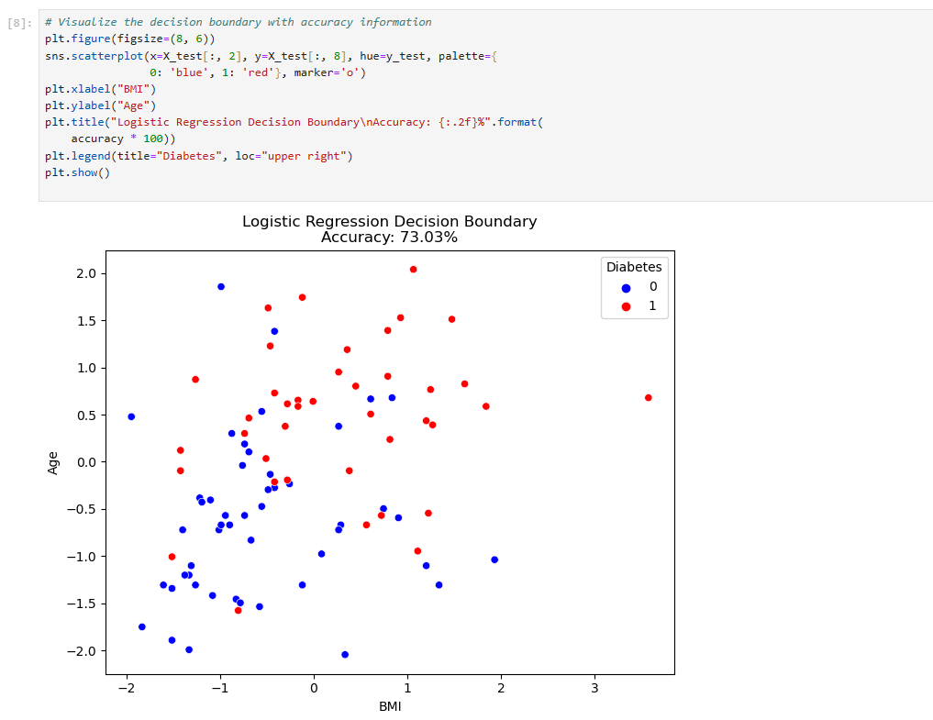

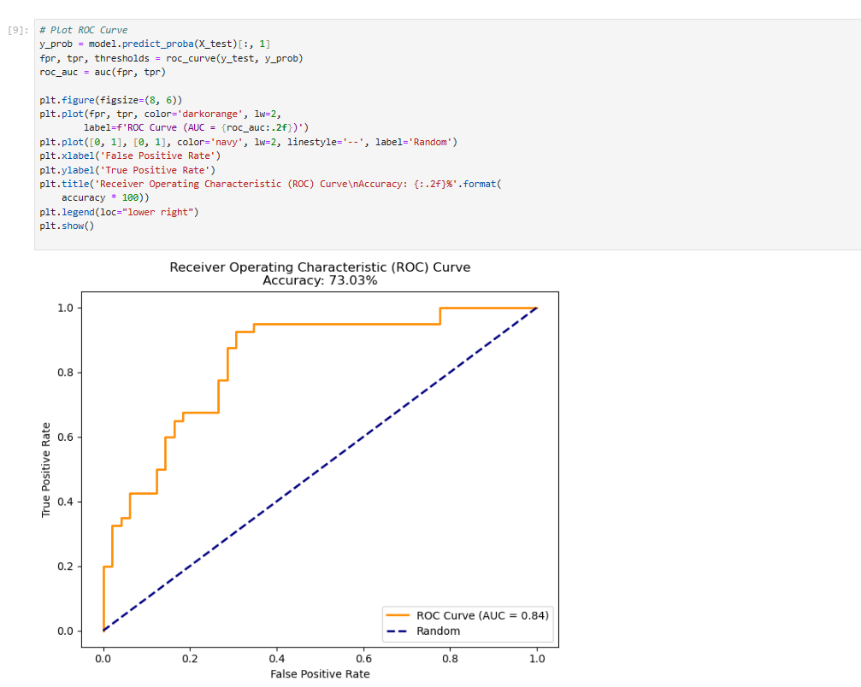

#### **4. Plotting ROC Curve:**